Case 7-AM,S-Peru-Moche-Tumi Ring-Copper-1200-1400 BCE
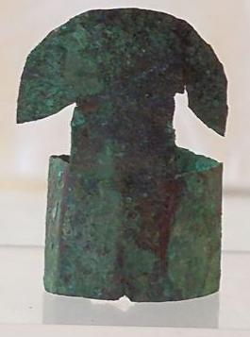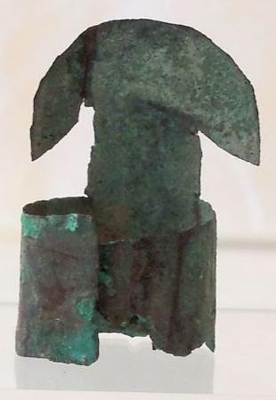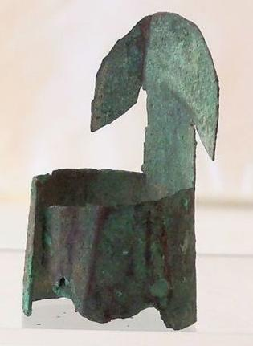
Case no.: 7
Accession Number: A74
Formal Label:
Display Description:
This ring is a symbolic form of a tumi blade (8-12 in. across). In Peru, to hang a tumi on a wall means good luck. Perhaps this ring is meant to bring luck to its wearer.
LC Classification: F3430.1.
Date or Time Horizon: 100 BCE-400 CE
Geographical Area: N coastal Peru
Map, GPS coordinates:
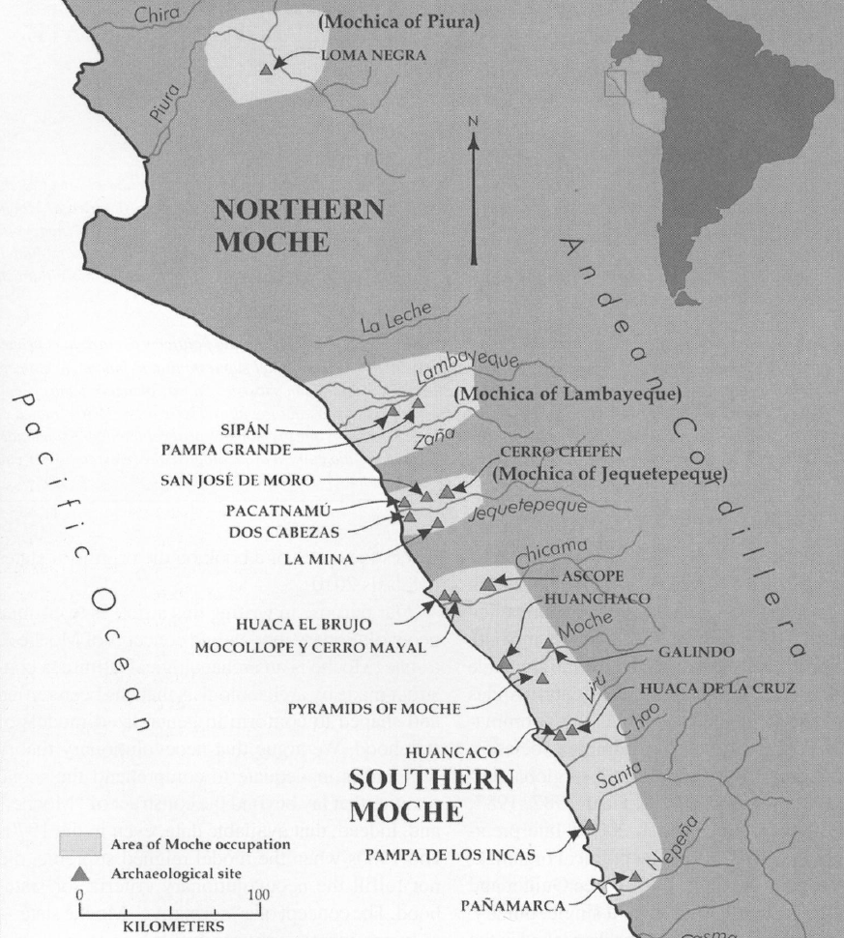
Fig. 3. Map of Moche regions as currently conceived and significant Moche sites. Map courtesy Moro Archaeological program.
Cultural Affiliation: Moche (Mochica)
Medium: Copper sheet with heavy encrusted verdigris patina. Ancient, cuprite and metallic sediment deposits yields a beautiful olive-green to brown patina on reverse and olive-green on obverse.
Dimensions: 1.5 in. tall and, though adjustable, the ring size is c 10.
Weight:
Condition: Original. Ancient, cuprite and metallic sediment deposits yields a beautiful olive-green to brown patina on reverse and olive-green on obverse.
Provenance: Ex. Arte Primitivo, Ex. Howard Nowes Gallery “Art for Eternity”.

Discussion:
Other Andean cultures have used the tumi for the neurological procedure of skull trepanation. Many of these operations were carefully performed, suggesting that the surgery was done for the relief of some body disturbance other than that associated with injury, perhaps an organic or mental condition.
References:
Berezkin, Yuri. 1980. “An Identification of Anthropomorphic Mythological Personages in Moche Representations,” Ñawpa Pacha, 18:1-26.
Quilter, Jeffrey. 1990. “The Moche Revolt of the Objects,” Latin American Antiquity, 1:42-65.
Quilter, Jeffrey.1997. “The Narrative Approach to Moche Iconography,” Latin American Antiquity, 8:113-133.
Quilter, Jeffrey. 2002. “Moche Politics, Religion, and Warfare,” Journal of World Prehistory, 16:145-195.
Quilter, Jeffrey. 2008. “Art and Moche Martial Arts.” In The Art and Archaeology of the Moche, edited by Bourget, Steve and Kimberly L. Jones, pp. 215-228. Austin: University of Texas.
Quilter, Jeffrey. 2010. Moche: Media and Messages. Cambridge: Peabody Museum Press, Harvard University.
Quilter, Jeffrey, and Luis Jaime Castillo Butters (editors) 2010. New Perspectives on Moche Political Organization. Cambridge: Dumbarton Oaks.
Quilter, Jeffrey, and Michele L. Koons, M. 2012. “The fall the Moche: a critique of claims for South America’s first state,” Latin American Antiquity, 23(2), 127-143.

Delivery package 1 of 1
Estimated delivery Wednesday, Dec 23, 2015 - Monday, Dec 28, 2015
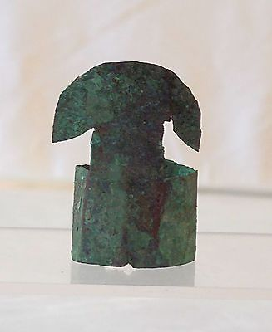

Guaranteed 100 % Authentic Pre-Columbian Peru Bronze Tumi Ring
Item price | $65.00
Quantity | 1
Item number | 121840433680
Shipping service | USPS Priority Mail

